Before changing the permission:

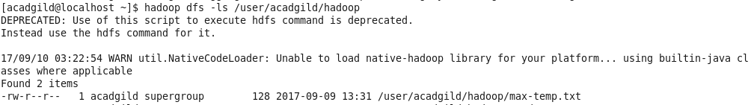

After changing the permission:

